Compact Robot Arm (Arduino) - 3D Printed
Servo Types | MG996R  20KG RC Servo  Micro Servo
Stepper Types | N/A
Meets
Requirements
Encoder Types | N/A | 𝚇
DoF | 5 | ✔
Size | 0.3m-0.4m | ✔
Type | 3D print | ✔
Hand | Yes | ✔
Compact Robot Arm (Arduino) - 3D Printed by BuildSomeStuff - ThingiverseHow to Build a 3D Printed Robot Arm Tutorial (Arduino Based) - Part One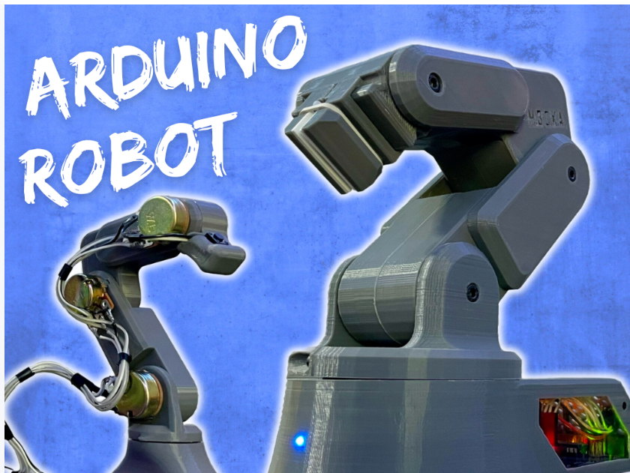
Part Links:
Servos: https://amzn.to/45xkgPH
20KG Servo: https://amzn.to/43sGe4c
Micro Servo: https://amzn.to/3N3g3fj
Arduino Board: https://amzn.to/3qfOmHg
Servo Driver Board: https://amzn.to/3spBGz1
Potentiometers: https://amzn.to/3QujXy4
Filament: https://amzn.to/3WNHGfx
Gripper Gears: https://amzn.to/42eLIyz
Screws Larger Set: https://amzn.to/3C47ASK
Screws Small Set: https://amzn.to/4hwMq3z
Wire and Connectors: https://amzn.to/3qiVMth
T-Plugs: https://amzn.to/47df3g6
Adjustable Power Supply: https://amzn.to/46e27Xa
Wire/Shrink Wrap: https://amzn.to/3G3DEYU
Rubber Band: https://amzn.to/3so2O1n
LED: https://amzn.to/3FZen1U
Clear Acrylic: https://amzn.to/3FYc6nO
Gripper Foam Pad: https://amzn.to/3SCE8wA
Power Switch: https://amzn.to/3und1LK
Controller Push Button: https://amzn.to/3ufX1vh

Will need to substitute the potentiometers, listed servos and servo driver board for magnetic encoders or smart servos for position feedback

DIY 3D Printable Robotic Arm
Servo Types | MG995
Stepper Types | N/A
Meets
Requirements
Encoder Types | N/A | 𝚇
DoF | 6 | ✔
Size | 0.5m-0.7m | ✔
Type | 3D print | ✔
Hand | Yes | ✔
GitHub - AngelLM/Thor: DIY 3D Printable Robotic Arm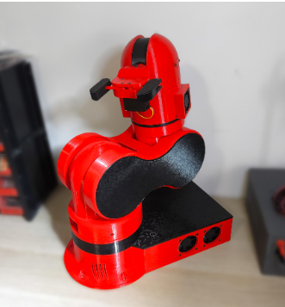

Thor is an open source, 3D printed, 6 degrees of freedom robotic arm. Designed to be affordable and accessible, Thor is ideal for educational settings, makers, and robotics enthusiasts. With a height of 625mm it has the capacity to lift up to 750g. Its yaw-roll-roll-yaw-roll-yaw configuration is common in industrial manipulators.

Parts list: Bill Of Materials – Thor
Brazo Robótico - THOR - YouTube (in spanish)

MOTUS - Open-Source 3D Printed Robotic ArmMOTUS - Open-Source 3D Printed Robotic Arm : 11 Steps (with Pictures) - Instructables
GitHub - ELISAVADevelopmentLab/MOTUS: Open-Source 3D Printed Robot Arm with 6-DoF created by ELISAVA Development Lab

Servo Types | N/A
Stepper Types | 17HS4401  23HS41-1804S  35HT36-1004A  17HS19-1684S-PG19
Meets
Requirements
Encoder Types | AS5600 | ✔
DoF | 6 | ✔
Size | 0.6m | ✔
Type | 3D print | ✔
Hand | No | 𝚇

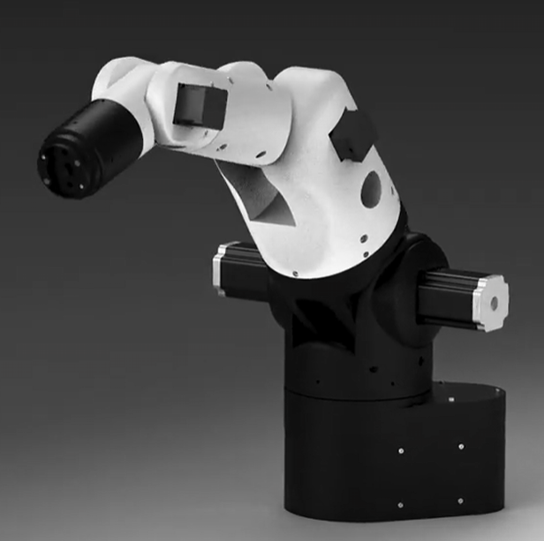
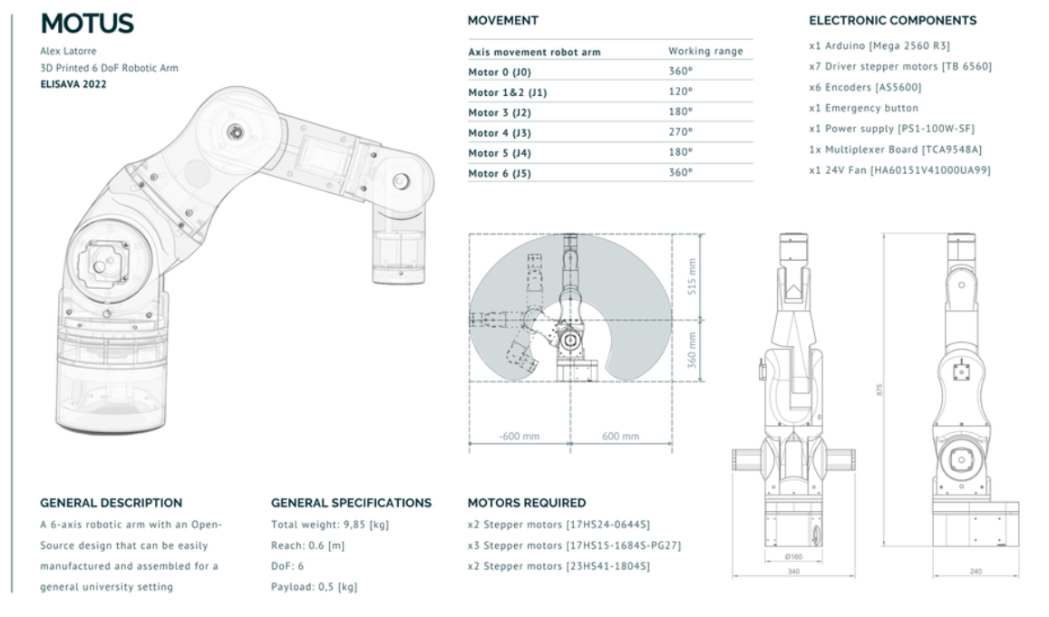

Parts List:
Arduino Mega 2560 R3 (x1)
17HS4401 (x2)
23HS41-1804S (x2)
35HT36-1004A (x1)
17HS19-1684S-PG19 (x2)
TB6560 Stepper Driver (x7)
51120-2RS Bearing (x1)
6816-2RS Bearing (x1)
688-2Rs (x3)
6810ZZ (x2)
AS5600 (x7) (magnetic encoders)
TCA9548A (x1) (I²C multiplexer)
F322DM 10x1 Radial Magnet (x7)
Pulley Wheel GT2 60T (x1)
6060/6082 T6 8x100 (x2)
Belt GT2 400 mm (x1)
Miscellaneous M3/M4/M5 DIN912 Bolts and Nuts

Faze4 Open Source Robotic Arm
Faze4 - 3D printed 6 axis robot arm

Servo Types | N/A
Stepper Types | NEMA 23  NEMA 17  NEMA 14
Meets
Requirements
Encoder Types | N/A | 𝚇
DoF | 6 | ✔
Size | 0.8m-0.9m | ✔
Type | 3D print | ✔
Hand | No | 𝚇
GitHub - PCrnjak/Faze4-Robotic-arm: All files for 6 axis robot arm with cycloidal gearboxes .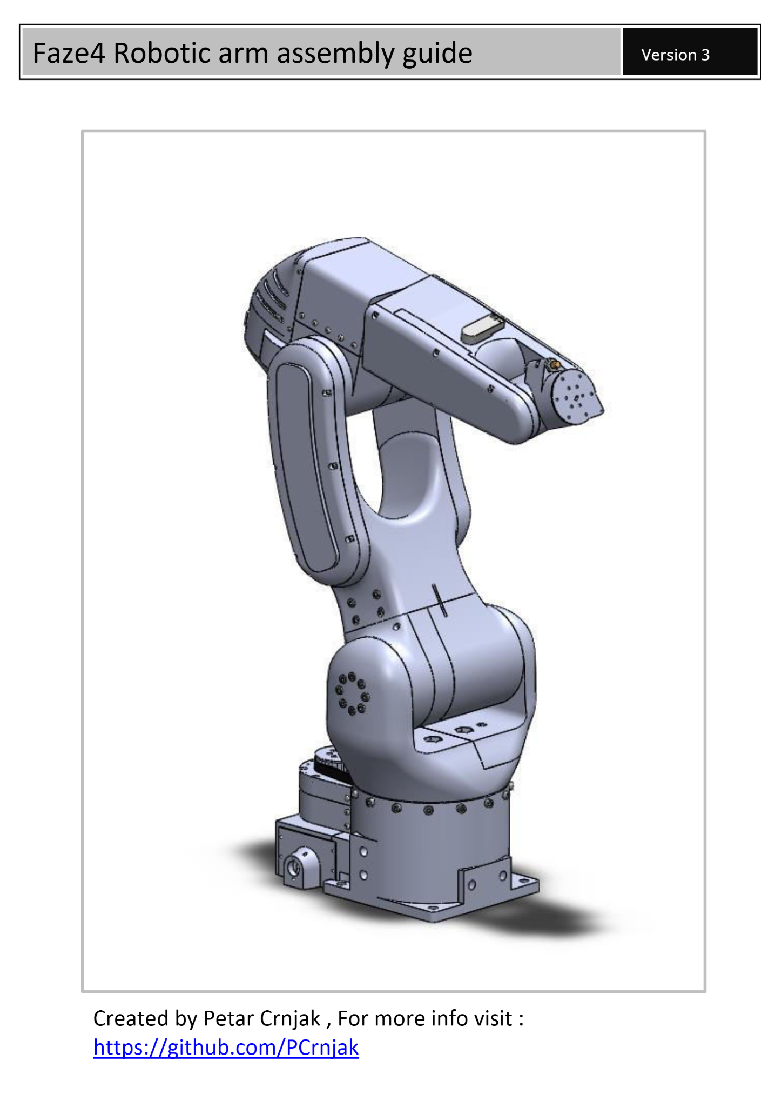

Parts List: BOM_7_11_2023.xlsx

The arm uses stepper motors with limit switches/inductive homing only. Joints are homed using inductive sensors (for joints 1 and 6) and limit switches on others. Position tracking in the firmware is done by counting steps sent to motors, not reading encoder feedback

Could be modified to use magnetic encoders

Open6x Robot Arm
Open6X robot arm | Hackaday.io

Servo Types | MG996R
Stepper Types | NEMA 17 40 mm  NEMA 23 76 mm  NEMA 23 56 mm  NEMA 14 28 mm  NEMA 17 34 mm
Meets
Requirements
Encoder Types | N/A | 𝚇
DoF | 6 | ✔
Size | 0.7m | ✔
Type | 3D print | ✔
Hand | Yes | ✔
Open6X/BUILD-INSTRUCTIONS/rev0 at main · jk87/Open6X · GitHub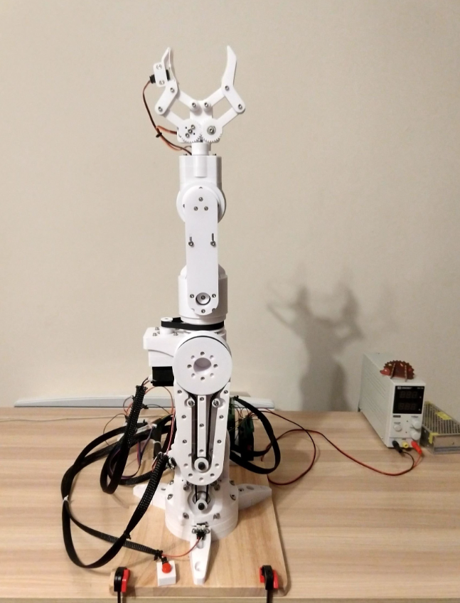

Part List: Open6X/BoM/rev0/Open6X-BILL-OF-MATERIALS.pdf at main · jk87/Open6X · GitHub

RR1: Real Robot One - a DIY Desktop Robotic Arm
RR1: Real Robot One - a DIY Desktop Robotic Arm | Hackaday.io

Servo Types | N/A
Stepper Types | Nema 23 112mm  Nema 23 80mm  Nema 23 76mm  Nema 23 54mm  Nema 17 59mm  Nema 17 42mm  Nema 17 39mm
Meets
Requirements
Encoder Types | AMT 103V  AMT 102V | ✔
DoF | 6 | ✔
Size | 0.8m | ✔
Type | 3D print | ✔
Hand | Yes | ✔
GitHub - surynek/RR1: RR1: Real Robot One - a DIY 3D-Printable Desktop Robotic Arm. RR1 is a 6-axis robotic arm based on 3D printed parts, uses stepper motors Nema 23 and Nema 17 and custom (split ring) planetary gearboxes.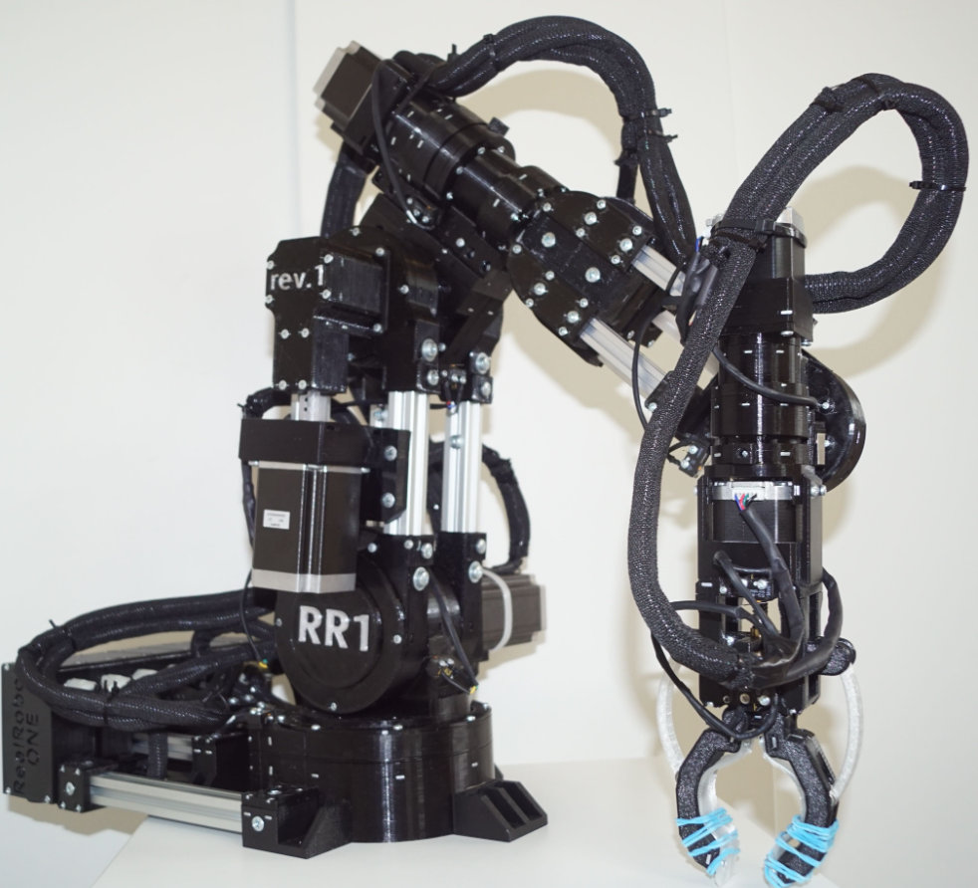

1 × Nema 23 Stepper motor 112mm
1 × Nema 23 Stepper motor 80mm
1 × Nema 23 Stepper motor 76mm
1 × Nema 23 Stepper motor 54mm
1 × Nema 17 Stepper motor 59mm
1 × Nema 17 Stepper motor 42mm
1 × Nema 17 Stepper motor 39mm with threaded shaft
6 × AMT 103V Encoder (rev. 2) or AMT 102V Encoder (rev,1)
1 × AMT 102V Encoder
Robotic Arm

PAROL6-Desktoop-robot-arm
GitHub - PCrnjak/PAROL6-Desktop-robot-arm: BOM, STL files and instructions for PAROL6 3D printed robot arm
PAROL6 - 3D printed robot arm - Repeatability : r/arduino
Servo Types | N/A
Stepper Types | Nema 17 16Ncm  Nema 17 45Ncm  Nema 17 65Ncm
Meets
Requirements
Encoder Types | N/A | 𝚇
DoF | 6 | ✔
Size | 0.4m | ✔
Type | 3D print | ✔
Hand | Yes | ✔
Source Robotics - YouTube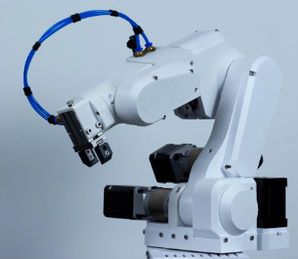

Parts list: PAROL6-Desktop-robot-arm/BOM/PAROL6 BOM_LATEST_12_12.pdf at main · PCrnjak/PAROL6-Desktop-robot-arm · GitHub

